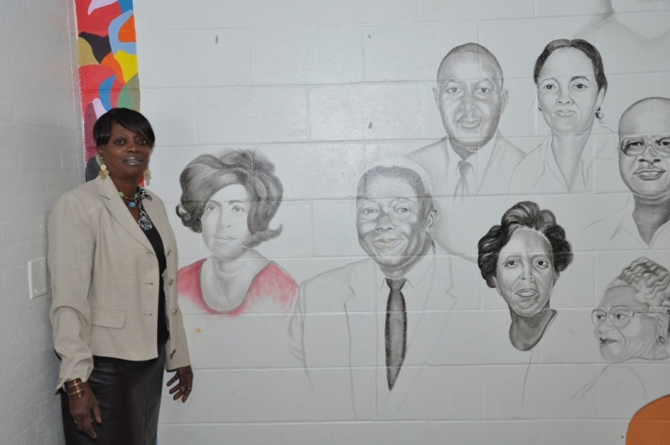
Ms Mamie Oatis, Principal of Southwestern Middle School, stands next to the mural (being painted by Gina Hickman) representing the Southwestern family. The mural in the School Way Cafe' begins with some of the individuals from Southwestern High School's staff (1962-1969)
The Southwestern Middle School Family is putting together a "Story of Southwestern." It will cover the time from January 1962 when the doors opened to Southwestern High School, through the years of Southwestern Seventh Grade Center (1969 - 1988) to the present Southwestern Middle School. The story will posted on southwesternmiddle.org (this site will be active the beginning of December) for all to access. The hope is for all those who have attended, taught , worked or even had a family member at Southwestern during this time frame would help us by contributing to our effort. The idea is to gather stories (short or long) with remembrances of an individual/s or events that marked your time here.
The writing of these stories would be done on forms that would allow you to put down your story. Access to these blank forms would be from an online source, they would also be available through community churches and at Southwestern Middle School. We have pictures and yearbooks from most of these years and are hoping to borrow the missing years to scan them digitally. These pictures would correspond with your stories of individuals.
January 28th, 2012 would be the collection day in the form of a bar-b-que at the Southwestern Middle School. Three screens in the school cafe would be showing continuously the yearbooks from this entire era. There will be an open mike for sharing. The price of admission to the event bar-b-que will be your completed story form. The bar-b-que will be pulled pork sandwiches, Southwestern baked beans (beans with attitude), cole slaw and sweet tea (some unsweet, also). We are hoping for a grand turnout to mark the roughly 50 years of your school. We would hope for you to spread the word of this event to your friends, family and fellow classmates or workmates. If you are unable to attend, we still hope for your input in a written form. The website will have an e-mail contact (southwesternmshistory@gmail.com) to download your stories earlier than the bar-b-que date in January. There will be other reminders from media sources, your church and the school. Remember the date, the food and most importantly your very special remembrance.
See you there
Your Southwestern Family

